Principles of Eddy Current

Understanding Coils
A coil of copper wire is the common method of inducing eddy currents. Alternating current running through a coil creates magnetic fields in and around the coil. The magnetic fields form loops around the wire and join to form larger loops. If the current increases in one loop, the magnetic field will expand across some or all of the loops of wire that are in close proximity. This induces a voltage in the neighboring loops and causes electron flow, or eddy currents, in electrically conductive material. Any defect in the material including changes in wall thickness, cracks, pitting and other discontinuities, change the flow of eddy currents and are measurable on eddy current instruments. The enhanced eddy current systems offered by UniWest provide superb sensitivity with the clearest display for a wide range of applications.

Ohm's Law
Ohm's Law is one of the most basic formulas to determine electrical flow. The voltage, divided by resistance in Ohms, determines electrical current, in Amperes.
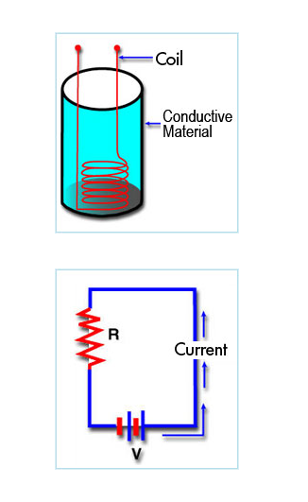

Inductance
Alternating current running through a coil creates a magnetic field in and around the coil that is building and collapsing as the current changes. As current increases, the coil becomes more magnetic and induces circulating (eddy) currents in conductive material that is near the coil. The amplitude and phase of the eddy currents will change the loading of the coil and its impedance. If a surface or sub-surface discontinuity exists in a conductive material, the eddy currents will be interrupted and the flow can be measured by UniWest's instruments. UniWest offers single channel / single frequency, single channel / dual frequency, and multi-channel instruments. Multi-channel detects and measures several flaws simultaneously. Frequencies range from 100 Hz to 10 MHz so that several types of materials can be analyzed for defects. Higher frequencies typically find cracks closer to the surface and lower frequencies penetrate further into the sub-surface of materials.
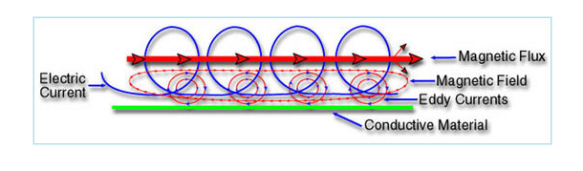

Magnetic Fields
The illustration on the left shows how electric currents form magnetic fields in coils. The coils in turn, form eddy currents in conductive material and also form their own magnetic fields. If a sub-surface discontinuity exists, the eddy current method will find it unless a crack is lying parallel to the current's path. When a crack is parallel to the current it may not cause a disruption of continuity and therefore won't show the flaw.
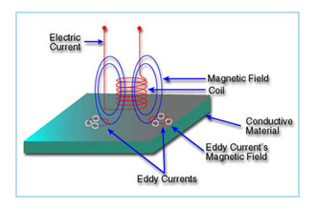

Flaw Detection
Changing the voltage across the coil will affect the material being scanned and allow the eddy current instrument to measure surface and sub-surface discontinuities. Several factors will influence the way flaws can be detected including the following: The conductivity of the material has a dramatic effect in the way eddy currents travel through the surface and sub-surface of materials. The more conductive the material is, the greater the flow of eddy currents. Permeability of the conductive material also has a dramatic effect because of its ability to be magnetized. Geometry plays an important role in detection as well. A flat surface is much easier to scan than an irregular surface. UniWest produces several special application probes that are contoured to the part being scanned for consistent coil placement throughout the specified depth of penetration. Depth of penetration makes a significant difference in the success of the inspection. A surface crack is much easier to detect than a sub-surface flaw. Selection of the proper frequency is critical to finding flaws. How the coil is configured, how many wraps, what size wire and where the coil is placed in the probe all make significant changes in the way defects are seen. Since the surface area is being magnetized, one of the most important factors in determining flaws is contact with the surface and lift off. When the coil is lifted from the surface, magnetic energy stops and eddy currents cease to exist. Even a small amount of lift off can have dramatic effects on the decrease of currents.
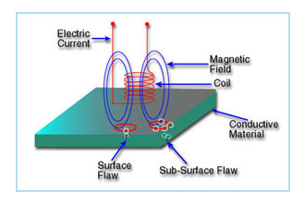

Contour Flaw Detection
There are hundreds of standard and special application probes that are produced for specific surface types and contours. Edges, grooves, contours, circumferentiation and metal thickness all contribute to the success or failure of the testing. A coil that is positioned close to the surface of the conductive material will have the best chance of discovering discontinuities. For difficult contours a coil is inserted into a special shoe and attached to a fixture that will allow the coil to traverse close to the suspect section. Many applications require special shaped probe bodies and coils to adapt to the irregular shape of the part. The coil may also be shaped to fit the design of the part. UniWest special application probes are well known in the eddy current industry for innovative crack detection on hard to inspect contours.

Eddy Current Probes
Three major types of probe are surface, outside diameter and inside diameter. These three configurations, as well as some cross over designs, are used for most flaw detection applications. Absolute probes have single coil design and give an 'absolute' reading at the flaw. Differential probes use two coils to check for flaws in different areas or to differentiate between two variables. Reflection probes have a primary coil being supplied by the oscillator and at least one coil from the measurement circuit. Reflection probes can be either absolute or differential.
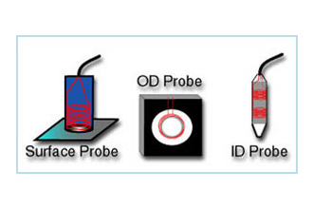

Formula
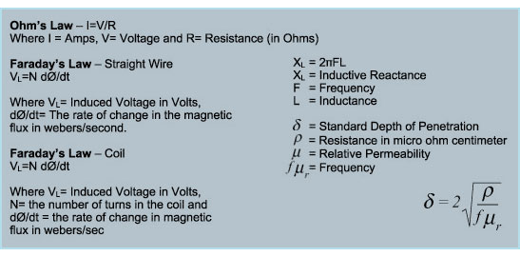

Hysteresis Eddy Current Iron or Core Losses and Copper Loss in Transformer

Losses in Transformer

As the electrical transformer is a static device, mechanical loss in transformer normally does not come into picture. We generally consider only electrical losses in transformer. Loss in any machine is broadly defined as difference between input power and output power. When input power is supplied to the primary of transformer, some portion of that power is used to compensate core losses in transformer i.e. Hysteresis loss in transformer and Eddy current loss in transformer core and some portion of the input power is lost as I²R loss and dissipated as heat in the primary and secondary windings, because these windings have some internal resistance in them. The first one is called core loss or iron loss in transformer and the later is known as ohmic loss or copper loss in transformer. Another loss occurs in transformer, known as Stray Loss, due to Stray fluxes link with the mechanical structure and winding conductors.

Copper Loss in Transformer

Copper loss is I²R loss, in primary side it is I₁²R₁ and in secondary side it is I₂²R₂ loss, where I₁ & I₂ are primary & secondary current of transformer and R₁ & R₂ are resistances of primary & secondary winding. As the both primary & secondary currents depend upon load of transformer, copper loss in transformer vary with load.

Core Losses in Transformer
Hysteresis loss and eddy current loss, both depend upon magnetic properties of the materials used to construct the core of transformer and its design. So these losses in transformer are fixed and do not depend upon the load current. So core losses in transformer which is alternatively known as iron loss in transformer can be considered as constant for all range of load.
Hysteresis loss in transformer is denoted as,
Eddy current loss in transformer is denoted as,
Where, K_{h} = Hysteresis constant.
K_{e} = Eddy current constant.
K_{f} = form constant.
Copper loss can simply be denoted as,
I_{L}²R₂′ + Stray loss
Where, I_{L} = I₂ = load of transformer, and R₂′ is the resistance of transformer referred to secondary.
Now we will discuss Hysteresis loss and Eddy current loss in little bit more details for better understanding the topic of losses in transformer

Hysteresis Loss in Transformer
Hysteresis loss in transformer can be explained in different ways. We will discuss two of them, one is physical explanation and the other is mathematical explanation.

Physical Explanation of Hysteresis Loss
The magnetic core of transformer is made of ′Cold Rolled Grain Oriented Silicon Steel′. Steel is very good ferromagnetic material. This kind of materials are very sensitive to be magnetized. That means, whenever magnetic flux would pass through, it will behave like magnet. Ferromagnetic substances have numbers of domains in their structure. Domains are very small regions in the material structure, where all the dipoles are paralleled to same direction. In other words, the domains are like small permanent magnets situated randomly in the structure of substance. These domains are arranged inside the material structure in such a random manner, that net resultant magnetic field of the said material is zero. Whenever external magnetic field or mmf is applied to that substance, these randomly directed domains get arranged themselves in parallel to the axis of applied mmf. After removing this external mmf, maximum numbers of domains again come to random positions, but some of them still remain in their changed position. Because of these unchanged domains, the substance becomes slightly magnetized permanently. This magnetism is called " Spontaneous Magnetism". To neutralize this magnetism, some opposite mmf is required to be applied. The magneto motive force or mmf applied in the transformer core is alternating. For every cycle due to this domain reversal, there will be extra work done. For this reason, there will be a consumption of electrical energy which is known as Hysteresis loss of transformer.

Mathematical Explanation of Hysteresis Loss in Transformer

Determination of Hysteresis Loss
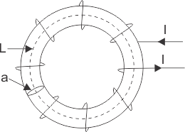
Consider a ring of ferromagnetic specimen of circumference L meter, cross - sectional area a m² and N turns of insulated wire as shown in the picture beside,
Let us consider, the current flowing through the coil is I amp,
Magnetizing force,
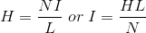
Let, the flux density at this instant is B,
Therefore, total flux through the ring, Φ = BXa Wb
As the current flowing through the solenoid is alternating, the flux produced in the iron ring is also alternating in nature, so the emf (e′) induced will be expressed as,

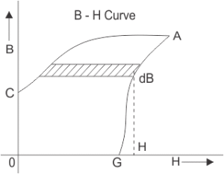
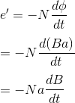
According to Lenz,s law this induced emf will oppose the flow of current, therefore, in order to maintain the current I in the coil, the source must supply an equal and opposite emf. Hence applied emf ,
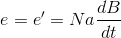Energy consumed in short time dt, during which the flux density has changed,
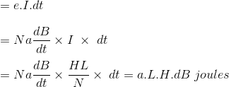
Thus, total work done or energy consumed during one complete cycle of magnetism,
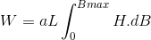
Now aL is the volume of the ring and H.dB is the area of elementary strip of B - H curve shown in the figure above,
Therefore, Energy consumed per cycle = volume of the ring X area of hysteresis loop.
In the case of transformer, this ring can be considered as magnetic core of transformer. Hence, the work done is nothing but the electrical energy loss in transformer core and this is known as hysteresis loss in transformer.

What is Eddy Current Loss ?
In transformer, we supply alternating current in the primary, this alternating current produces alternating magnetizing flux in the core and as this flux links with secondary winding, there will be induced voltage in secondary, resulting current to flow through the load connected with it. Some of the alternating fluxes of transformer; may also link with other conducting parts like steel core or iron body of transformer etc. As alternating flux links with these parts of transformer, there would be a locally induced emf. Due to these emfs, there would be currents which will circulate locally at that parts of the transformer. These circulating current will not contribute in output of the transformer and dissipated as heat. This type of energy loss is called eddy current loss of transformer. This was a broad and simple explanation of eddy current loss. The detail explanation of this loss is not in the scope of discussion in that chapter.

Transformer - Losses And Efficiency

Losses In Transformer
In any electrical machine, 'loss' can be defined as the difference between input power and output power. An electrical transformer is an static device, hence mechanical losses (like windage or friction losses) are absent in it. A transformer only consists of electrical losses (iron losses and copper losses). Transformer losses are similar to losses in a DC machine, except that transformers do not have mechanical losses.
Losses in transformer are explained below -

(I) Core Losses Or Iron Losses
Eddy current loss and hysteresis loss depend upon the magnetic properties of the material used for the construction of core. Hence these losses are also known as core losses or iron losses.
- Hysteresis loss in transformer: Hysteresis loss is due to reversal of magnetization in the transformer core. This loss depends upon the volume and grade of the iron, frequency of magnetic reversals and value of flux density. It can be given by, Steinmetz formula:
W_{h}= ηB_{max}^{1.6}fV (watts)
where, η = Steinmetz hysteresis constant
V = volume of the core in m³

- Eddy current loss in transformer: In transformer, AC current is supplied to the primary winding which sets up alternating magnetizing flux. When this flux links with secondary winding, it produces induced emf in it. But some part of this flux also gets linked with other conducting parts like steel core or iron body or the transformer, which will result in induced emf in those parts, causing small circulating current in them. This current is called as eddy current. Due to these eddy currents, some energy will be dissipated in the form of heat.

(Ii) Copper Loss In Transformer
Copper loss is due to ohmic resistance of the transformer windings. Copper loss for the primary winding is I₁²R₁ and for secondary winding is I₂²R₂. Where, I₁ and I₂ are current in primary and secondary winding respectively, R₁ and R₂ are the resistances of primary and secondary winding respectively. It is clear that Cu loss is proportional to square of the current, and current depends on the load. Hence copper loss in transformer varies with the load.

Efficiency Of Transformer
Just like any other electrical machine, efficiency of a transformer can be defined as the output power divided by the input power. That is efficiency = output / input .
Transformers are the most highly efficient electrical devices. Most of the transformers have full load efficiency between 95% to 98.5% . As a transformer being highly efficient, output and input are having nearly same value, and hence it is impractical to measure the efficiency of transformer by using output / input. A better method to find efficiency of a transformer is using, efficiency = (input - losses) / input = 1 - (losses / input).

Condition For Maximum Efficiency
Let,
Copper loss = I12R1
Iron loss = Wi
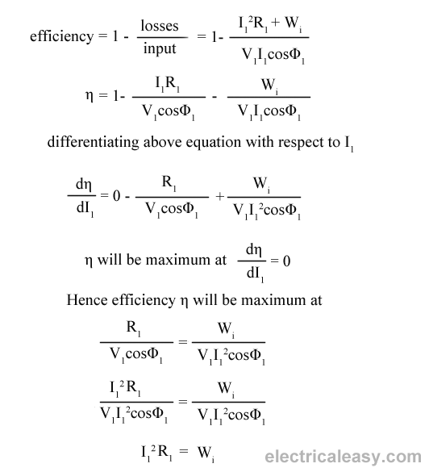
Hence, efficiency of a transformer will be maximum when copper loss and iron losses are equal.
That is Copper loss = Iron loss.

All Day Efficiency Of Transformer
As we have seen above, ordinary or commercial efficiency of a transformer can be given as

But in some types of transformers, their performance can not be judged by this efficiency. For example, distribution transformers have their primaries energized all the time. But, their secondaries supply little load all no-load most of the time during day (as residential use of electricity is observed mostly during evening till midnight).
That is, when secondaries of transformer are not supplying any load (or supplying only little load), then only core losses of transformer are considerable and copper losses are absent (or very little). Copper losses are considerable only when transformers are loaded. Thus, for such transformers copper losses are relatively less important. The performance of such transformers is compared on the basis of energy consumed in one day.
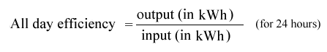
All day efficiency of a transformer is always less than ordinary efficiency of it.

